Access Scratch Through this link : <https://scratch.mit.edu/>

Activity 1: Students will be responsible to identify the rule for the input/output table in problem 1 of the 5.1 worksheet. After the student believes they have identified the rule they will create this scratch project to use Computer Science to check their work with the input and output table of the worksheet.

1. Make an account by going on the Join Scratch tab present in the header of the website click on highlighted “Join Scratch”.



1. Follow prompts after pressing join scratch to create an account.

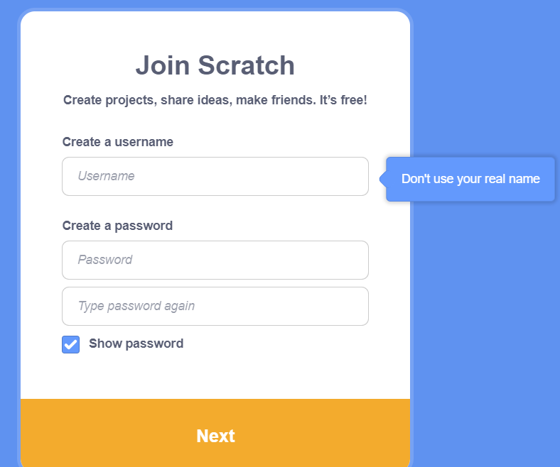

1. Once the account is set up press create highlighted in the top left corner of your screen.



Exercise 1:

1. In events pull the block below into the center window.
2. In sensing pull the block below into the center window and connect it to the bottom of the block used in the last step. Customize the message you would like to ask the user by typing the message in the white bubble. This will prompt the user for what x is set to in the input table. Feel free to use “What do you want x set to?” pictured on the right.

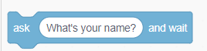

1. In variables click on the box below labeled “Make a variable” and make a variable filling out proper values for the named variable that will represent x in the input/output table. Feel free to use xVariable as I did present in the box below.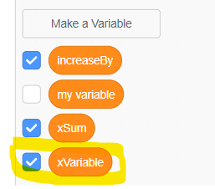

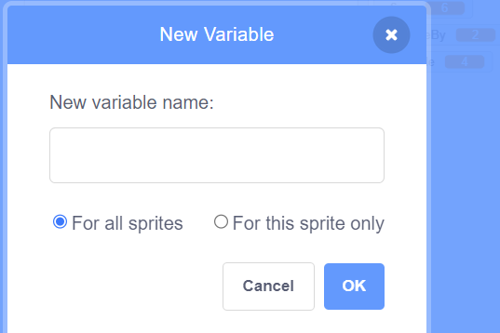

1. In the variables section pull the block below called “set my variable” to the screen and click mouse on my variable part and select the variable called xVariable then connect it to the bottom of the block used in the last step. In sensing drag the answer bubble into the position of the 0 in the “set my variable block.

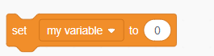

1. In sensing pull the block below into the center window connecting it to the bottom of the block used in the last step and customize the message you would like to ask the user by typing that message in the white bubble. This will be prompting the user for what y is set to in the input table. In the ask type “What do you want x to increase by?”.



1. In the variables click on “make a variable” and fill out proper values for the named variable that will represent the rule of which x will increase to represent y in the output. Feel free to use increaseBy as I did present in the box below.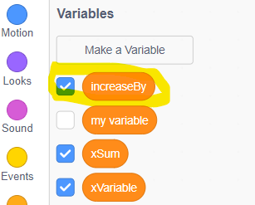



1. In the variables section pull the block below called “set my variable” to the screen and click mouse on my variable part and select the variable called increaseBy above then connect it to the bottom of the block used in the last step. Then in sensing drag the answer bubble into the position of the 0 in the “set my variable block.



1. In variables click on the box below labeled “Make a variable” and make a variable filling out proper values for the named variable that will represent y in the input/output table. Feel free to use xSum as I did present in the box below.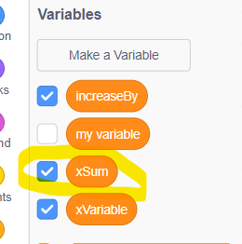





1. In the variables section pull the block below called “set my variable” to the screen and click the mouse on my variable part and select the variable called xSum above then connect it to the bottom of the block used in the last step. Then in the operators section select the addition bubble pictured below and drag that in the 0 spot. In the variable section pull the xVariable and drop it in the empty space on the left of the addition sign and pull the increaseBy and drop it in the empty space on the right of the addition sign. The final should look like the fourth picture below.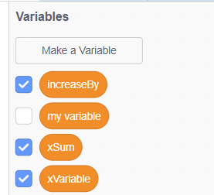



1. In looks, pull the say Hello! block below to the center window and connect it to the bottom of the block used in the last step. Then go into variables and select the custom variable that xSum and pull it into the place that says Hello!

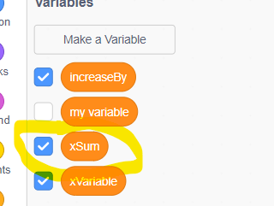

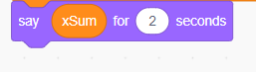

The full code should look like this :

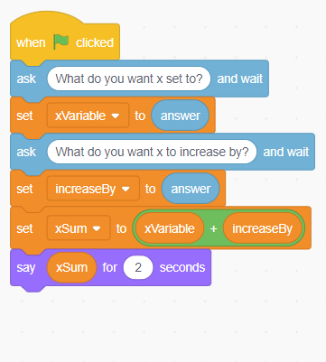

1. In order to run and see if the code is working press on the green flag on your screen near the stop sign.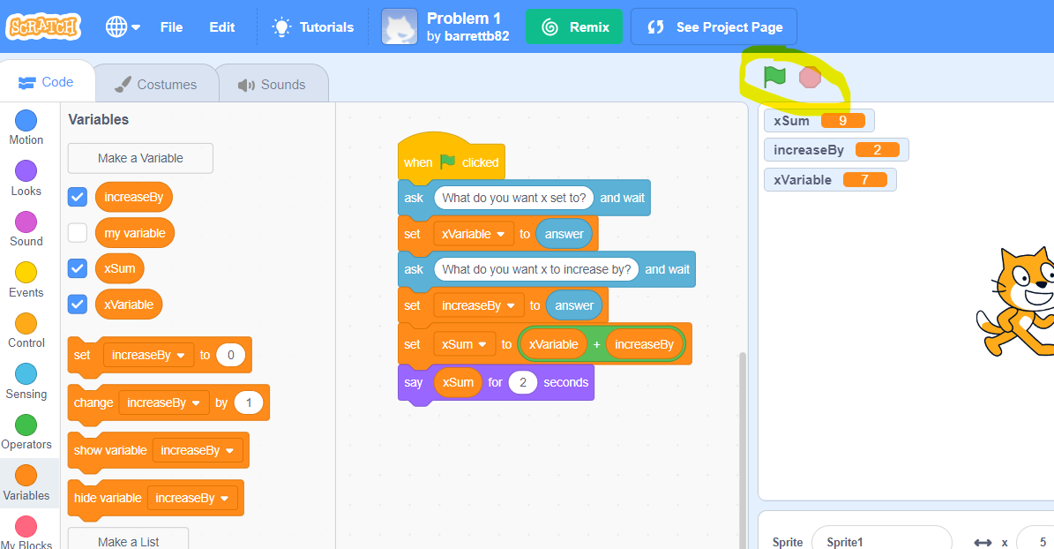

When running the application: When prompted first question enter a single input value each run. Press the green flag again on the first prompt enter 1, second prompt enter 2, should get the cat to say 3. Press the green flag again on the second prompt enter 4, second prompt enter 2, should get the cat to say 6. Press the green flag again on the second prompt enter 7, second prompt enter 2, should get the cat to say 9. The Values entered and returned represent the input output table on the worksheet.

